**NO 1. Banana plantation at Tambon Meng Rai, Phaya Meng Rai district, Chiang Rai and Jun District, Phayao**

**Field trip coordinator – Dr. Panitda Saiyarod**

**Context of the field site**

Recently, agricultural investment in Thai – Laos border, is becoming popular among new Chinese entrepreneurs aiming to serve Chinese and worldwide markets. Large-scale banana farms were established along the border of Thailand - Laos. In 2014 banana plantation covered a total area of 22,920 ha in Laos while there was a Chinese company has rent 1,200 acres in northern Thailand to establish the Cavendish banana plantation in 2015. However, since 2016 the Lao government has banned the opening of new banana plantation due to the intensive use of chemicals, overuse of fertilizer and pesticides, soil and water contamination.

In Thailand, the large scale banana plantation in Phaya Meng Rai district, Chiang Rai has also raised public concerns that it might have great impact on the environment in terms of agricultural pollution caused by and excessive chemical usage as well as conflict with surrounded community on the water competition. In addition, non-chemical banana contract farming that aims to serve Chinese market, are now gradually introduced to Jun district, Phayao and other district in northern Thailand.

**Transdisciplinary approaches in the field sites to explore**

**Environmental and Migration issues**

* Impact of current practice of chemicals using in banana plantation on health and environment
* Land use, access of public canal, pattern of shifting plantation; Geographic data, GIS mapping.
* Demographic outlook of the population worker in banana camp.
* Rights of ethnic workers in the banana camp.
* Benefit of local people in term of economic advantage

**The Role of Non-academic stakeholders**

The network of Ing river community: they are monitoring the issue of water competition, local fish species and environmental impact through their local networks in the villages along the Ing river.

**Contact person: -**

**Suggested accommodation & transportation:** Ban Suan Resort , Phaya MengRai , Hotel Fortune River view, NamKhong Hotel ,Chiang Khong / VAn

1. **suggested duration in the field**: 2 nights

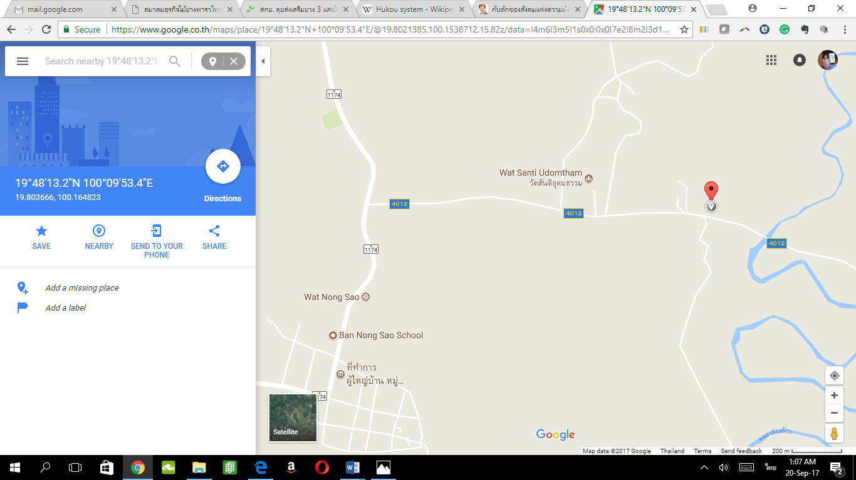

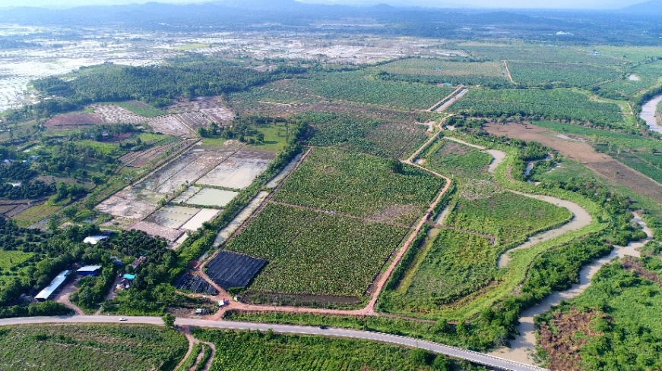

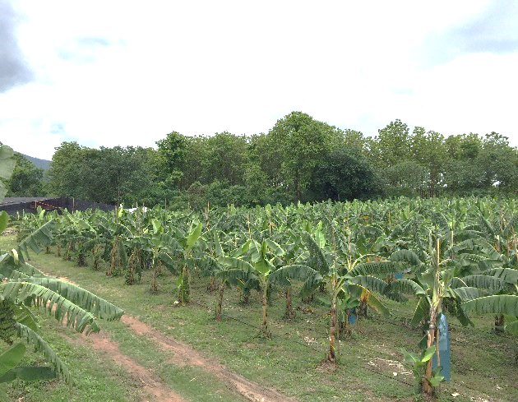

**_____________**

**NO 2 Chiang Khong**

**1) Context**

Chiang Khong is located in Chiang Rai Province where Mekong River is the borderline between Thailand and Lao PDR. Mekong communities depended on the river as a way of life from childhood to aging. The construction of hydro-power dams along Mekong River in China since 1996 are actually effected to Mekong River and people who live below as the river is regarded as a trans-boundary river. Local communities along Mekong River in Chiang Khong faced the impacts unavoidable, particularly, food resources and livelihoods. The case of fishing at Pak Ing Tai village illustrated lacking of Mekong fish from changing of river’s ecosystems, which effected to livelihoods of villagers and food resources in Chiangkhong. The case of freshwater weeds at Had Krai village illustrated impacts from the high water level that bring into losing of nutrient food and income sources of women in Chiang Khong.

**2) why the site has been chosen (in relations to the themes on environment, migration & inequality & transdisciplinary approach)**

2.1 Environment

Mekong River – river flows, water level changes rapidly, water contamination are the main ecological impacts in Mekong river that affected to Mekong communities in Chiang Khong; livelihoods (farmers and fishermen) and food scarcity. Women spend more working time and working tasks to afford family expense that resulted from men’s income decreasing.

2.2 Migration and mobility

Environmental changes forced Laotian and ethnic groups (from Lao PDR, Chiang Saen, Mae Sai) become migrant workers, especially, during semester break in Laos, many students crosses the river to work in town and rural area of Chiang Khong to gain more income.

2.3 Inequality

Both environmental and migration issues reflected to social inequality in access to resources of local communities along Mekong River by hydro-power dam development projects.

The transdisciplinary approach is in relevant by applying economist, biologist, ecologist, food scientist, political scientist, local government, social workers, NGO workers and communities to resolve.

**3) non-academic stakeholders and what is their role?**

- Rak Chiang Khong network, the local community movement in Chiang Khong takes responsibilities in monitoring and investigation of Chiang khong situations.

- Women for Change group, NGO workers and women group in Chiang Khong takes responsibilities in assistance and monitoring migrant worker situations, particularly, children and women.

- Local government takes a key role in decision-making development direction.

**4) Contact Persons**

Khun Ood, a coordinator of Rak Chiang Khong network and Kru Tie

Khun Loy, a coordinator of Women for Change

**5) Accommodation & transportation**

Accommodation: K.Wan, Baan Rim Taling Guesthouse (Free Wifi, Good command in English, Homemade breakfast and a member of Women for Change)

99/4 Soi 19, Vieng, Chiang Khong

Boat: K. Piek, a boatman (need to make an appointment)

Transportation: a van will be convenience for a group to travel around

**6) Duration in the field**

3 days/ 2 nights (include a half day travelling from Chiang Mai to Chiang Khong and a half day in return)

**7) maps and photos (if possible)**

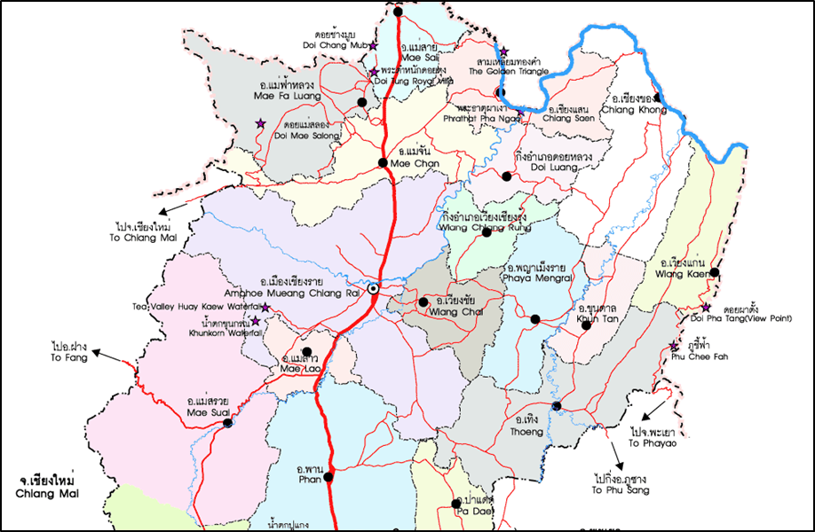

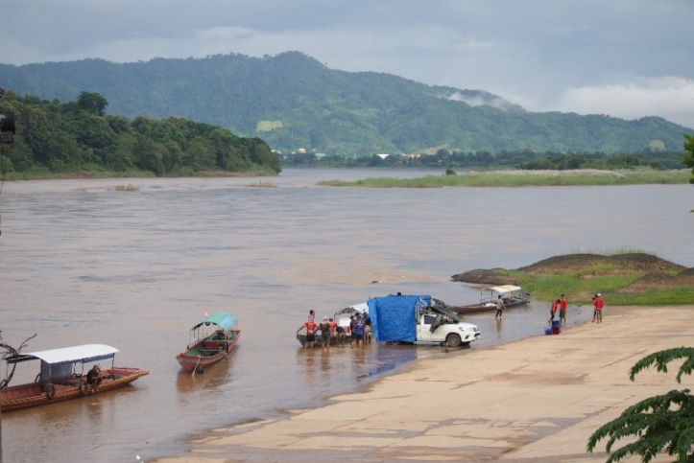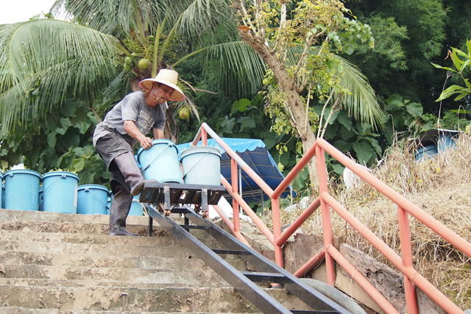

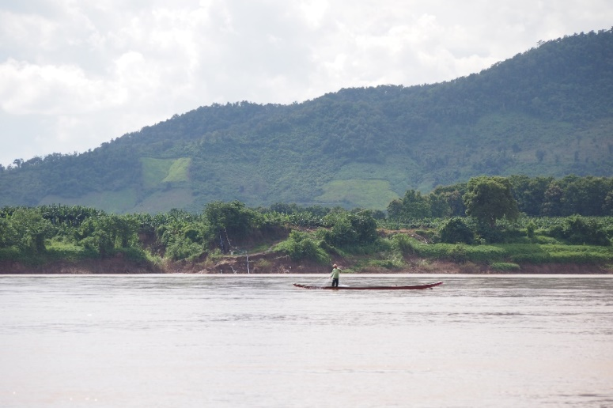

**No. 4 Nor Lae, Fang District, Chiang Mai**

บ้านนอแล อ.ฝาง จ.เชียงใหม่ เป็นชุมชนที่พักอาศัยแห่งแรกของ “ดาราอาง” หรือคนนอกมักจะเรียกพวกเขาว่า “ปะหล่อง” ที่หลบหนีปัญหาความขัดแย้งทางการเมืองจากประเทศเมียนมาร์เข้ามายังประเทศไทย ตั้งแต่ปี 2522 นำโดยนายนะโม หมั่นเฮิง ปัจจุบันอายุ 90 ปี ในปีพ.ศ.2524 ในหลวงรัชกาลที่9 ได้เสด็จมายังโครงการหลวงดอยอ่างขาง นายนะโมได้ถวายฎีกาขออาศัยอยู่ในประเทศไทย ในหลวงทรงอนุญาตให้ตั้งถิ่นฐานอยู่ที่บ้านนอแล แต่ในช่วงนั้นบริเวณบ้านนอแล เป็นพื้นที่ปลูกฝิ่นขนาดใหญ่ชาวดาราอางยังคงดำรงชีพด้วยการปลูกฝิ่น จนกระทั่งในปี 2527 ในหลวงรัชกาลที่ 9 เสด็จมาที่สถานีเกษตรหลวงอ่างขางอีกครั้งนายนะโมได้มีโอกาสเข้าเฝ้าเป็นครั้งที่ 2 ในครั้งนี้ในหลวงขอให้ชาวดาราอางเลิกปลูกฝิ่นและส่งเสริมอาชีพให้แก่ชาวบ้านแทนการปลูกฝิ่น ในปี 2532สถานีเกษตรหลวงอ่างขาง เริ่มเข้ามาส่งเสริมให้ปลูกไม้ผลเมืองหนาวแต่ไม่ได้ผลผลิตเท่าที่ควร จึงส่งเสริมให้ชาวบ้านปลูกผักเมืองหนาวใน ปี 2546 จากนั้นเป็นปลูกดอกกุหลาบไม้ดอกไม้ประดับ สตรอเบอร์รี่ และชา ตามลำดับ

ปัจจุบันบ้านนอแลเป็นบ้านบริวารของบ้านขอบด้ง หมู่ที่ 14 ตำบลม่อนปิ่น อำเภอฝาง จังหวัดเชียงใหม่ มีจำนวนประชากรทั้งหมด 1,300 คน 240 ครัวเรือน ผู้มีสัญชาติไทยจำนวน 276 คน ส่วนใหญ่ถือบัตรบุคคลบนพื้นที่สูงและบัตรผู้ไม่มีสถานะทางทะเบียน ชาวบ้านส่วนใหญ่นับถือศาสนาพุทธ ในชุมชนมีศูนย์รวมหลักคือวัด เสาใจบ้าน และศาลเจ้าเมือง ซึ่งถือว่าเป็นสิ่งที่สำคัญมากสำหรับชาวดาราอาง บ้านนอแลอยู่ห่างจากตัวอำเภอฝาง ประมาณ 30 กิโลเมตรอยู่ห่างจากสถานีเกษตรหลวงอ่างขางประมาณ 6 กิโลเมตรภายในชุมชนยังมีศูนย์เด็กเล็ก มีสำนักสงฆ์ และใกล้ชุมชนประมาณ 4 กิโลเมตรมีโรงเรียนบ้านขอบด้งซึ่งเป็นชุมชนของชาวลาหู่ส่วนใหญ่เด็กดาราอางบ้านนอแลจะเดินทางมาเรียนที่โรงเรียนแห่งนี้

อาชีพ และระบบเศรษฐกิจของชุมชน เนื่องจากชาวดาราอางเป็นผู้อพยพใหม่ จึงไม่มีสิทธิด้านที่ดินทำกิน และดังได้กล่าวมาแล้วว่า ชาวดาราอางส่วนหนึ่งได้ทำการเกษตรกับสถานีเกษตรหลวงอ่างขาง ปัจจุบันนี้มี 7 กลุ่ม คือกลุ่มสตรอเบอร์รี่ กลุ่มผักอินทรีย์ กลุ่มชาอินทรีย์ กลุ่มไม้ดอก กลุ่มสมุนไพรอินทรีย์ กลุ่มปศุสัตว์และกลุ่มเห็ดพอร์โทเบลโล ชาวดาราอางอีกกลุ่มหนึ่งที่อพยพมาระยะหลังและไม่ได้รับการจัดสรรที่เพาะปลูกจากสถานีเกษตรฯ กลุ่มนี้ได้ข้ามไปใช้ที่ดินทำกินในฝั่งประเทศเมียนมาร์ทำการเกษตรปลูกเผือก บัวหิมะและปลูกข้าวไร่ ในช่วง 1-2 ปีที่ผ่านมาเริ่มหยุดปลูกข้าวไร่แล้ว ปัจจุบันมีชาวบ้านที่ข้ามไปใช้ที่ดินฝั่งเมียนมาร์จำนวน137ครอบครัว และใช้พื้นที่ทั้งหมด 1,667 ไร่ โดยต้องเสียภาษีให้ทหารเมียนมาร์เฉลี่ยไร่ละ 700-1,000 บาทต่อปี นอกจากนั้น กลุ่มผู้หญิงยังมีรายได้จากการขายสินค้า เช่น เสื้อผ้า เครื่องประดับสตรีเช่น ต่างหู สร้อยคอ กำไล กระเป๋า ผ้าคลุมไหล่ให้แก่นักท่องเที่ยวที่เดินทางมาเที่ยวดอยอ่างขางในช่วงเดือนพฤศจิกายนถึงเดือนกุมภาพันธ์ ซึ่งสร้างรายได้ให้แก่กลุ่มผู้หญิงพอสมควร กลุ่มผู้หญิงยังมีอาชีพรับจ้างแบกของจากฝั่งไทยไปยังฝั่งเมียนมาร์ด้วย

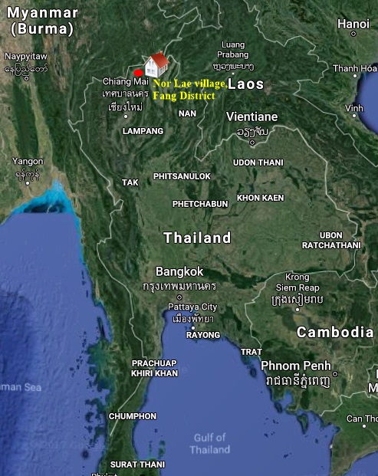

**_____________**

**No. 5 Bann Hin Ladd Nai, Chiang Rai (2.5 hours from CM)**

Huay Hin Lad Nai, Chiang Rai Province, Northern Thailand: The hamlet of Huay Hin lad Nai, an ethnic ‘Pgaz K’Nyau’ (Karen Sgwa) community, is located in between a National Forest Reservation area and Khun Jae National Park and 120 km. from ChiangMai province. Nowadays, the Huay Hin Lad Nai community is recognized by the Thai Government as a role model for the sustainable management of forest resources and for self-sufficient, environmentally friendly living (IFAD, 2013). The population is around 101 villagers from 21 households.

However, for decades, the community has struggled with the consequences of imposed State policies and practices and their adverse impacts on the villagers’ culture and traditional livelihoods. For example, in 1992, the government declared the area around Huay Hin Lad Nai as a National Park, and forest dwellers were asked to resettle. Due to a joint protest movement and the formation of networks between the community and other affected ethnic groups, the villagers were finally allowed to remain in their settlement (NDF, OXFAM 2011; IFAD 2013). Today, the community engages in traditional agroforestry farming, guided by their traditional knowledge, rituals, and community regulations for the control of resources (Trakansuphakon, 2010, p. 59). Income generating activities of the community comprise growing rice, wild tea, bamboo, a variety of cash crops and fruits, and the collection of forest products(NDF, OXFAM, 2011; IFAD, 2013). Their sustainable and self-sufficient resource management practices are based on rotational and integrated farming. These systems foster the protection and transmission of traditional knowledge and local culture, and ensure food sovereignty by promoting resource integration and diversified production systems. They contribute to poverty alleviation, especially through enhancing food security, and through minimizing market uncertainties and expenses for household food consumption (IFAD, 2013; Trakansuphakon, 2010, p. 54). Moreover, these systems represent strategies to adapt to and mitigate climate change impacts (NDF, OXFAM, 2011). In 1999, Huay Hin Lad Nai was recognized by various Thai government agencies for its sustainable resource management practices and environmental restoration efforts, and the village was officially entitled a “sustainable village” (IFAD, 2013, p.5).

**References**

International Fund for Agricultural Development (IFAD), PROCASUR Corporation, & the Asia Indigenous Peoples Pact (AIPP) (2013). *Managing Forest, Sustaining Lives, Improving Livelihoods of Indigenous Peoples and Ethnic Groups in the Mekong* Region, *Asia; Lessons Learned from the Learning Route.*

Northern Development Foundation (NDF), Huay Hin Lad Nai Community, & Oxfam (2011). *Climate Change, Trees and Livelihood: A Case Study on the Carbon Footprint of a Karen Community in Northern Thailand*. AIPP, NDF, IWGIA.

Trakansuphakon, P. (2010). Traditional Livelihoods, Food Security and Climate Change in Thailand. In Asia Indigenous Peoples Pact (AIPP) Foundation*, Traditional Livelihoods and Indigenous Peoples* (pp. 51-64). AIPP Printing Press, Thailand

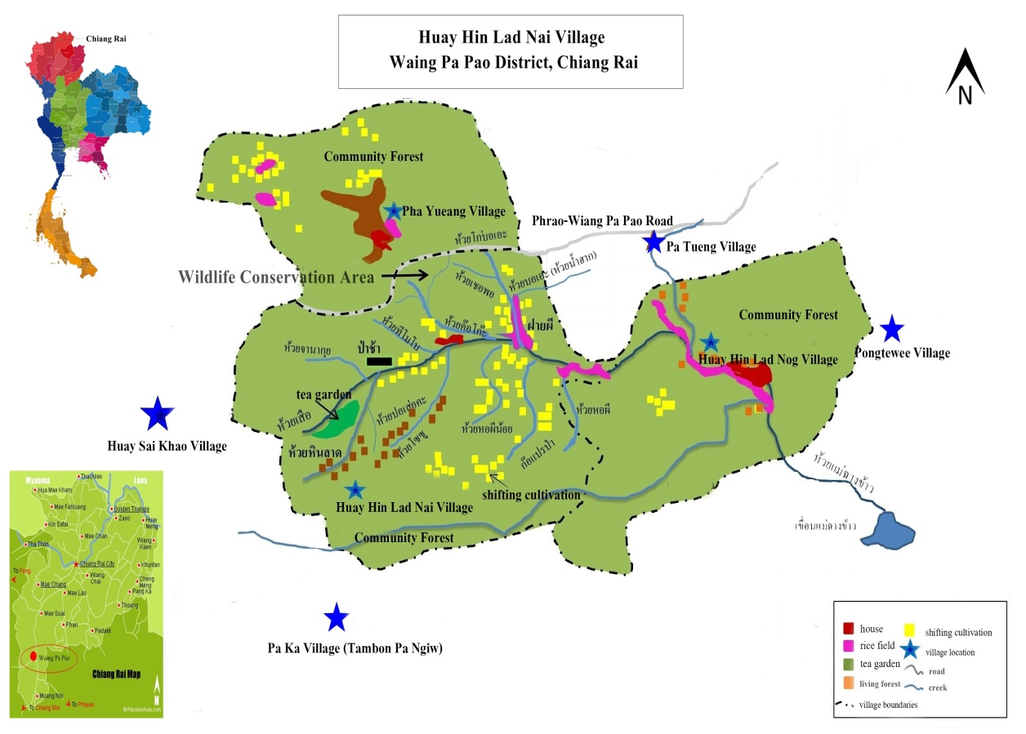

**_____________**

**No. 6 Mae Kha Canal for the Field Trip’s Transdisciplinary Study Site**

Ta-Wei Chu (David)

Lecturer, Department of Social Science and Development, Chiang Mai University,

E-mail: nukuma0939888470@hotmail.com

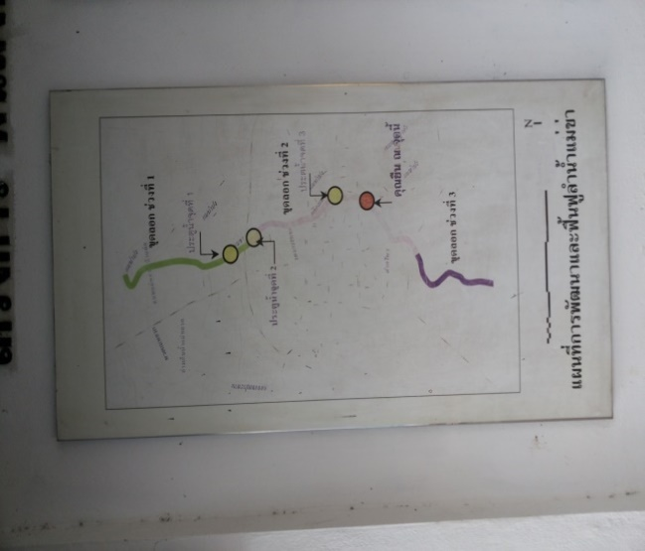Mae Kha is a significant canal in Chiang Mai City, the second most-populated city in Thailand. It originates north of the City Moat and merges with Lumkuwai Creek, which is located southeast of the moat, before finally reaching Ping River, a tributary of the Chao Phraya River. During the 1950s, Mae Kha was a clean canal. Local people used the water for drinking and irrigating. They also caught fish for food from the canal. In short, local people relied on the Mae Kha Canal for their livelihoods.

Since the 1960s, Chiang Mai City has experienced rapid development. From 1962 to 1980, the Thai government implemented the first four national economic and social development plans. The aim of the plans was to facilitate industrialisation in Thailand. The Thai government also created five-year plans (1977–1981) in order to develop the cities outside Bangkok (Ribeiro & Srisuwan 2005: 173). Chiang Mai was one of the targeted cities.

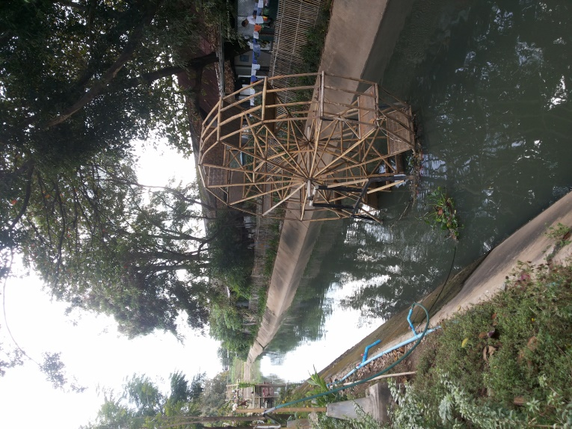Industrialisation and Urbanisation have transformed Chiang Mai City into a tourist attraction, which has created many job opportunities. These opportunities have impressed people living in rural districts of Chiang Mai Province and hill-tribe people from the mountains surrounding Chiang Mai Province, triggering a mass migration to Chiang Mai City (Ribeiro & Srisuwan 2005: 174). Many of these migrants have been economically vulnerable and have worked in informal sectors. Unable to afford proper housing, marginalized migrants have created informal settlements along the Mae Kha Canal.

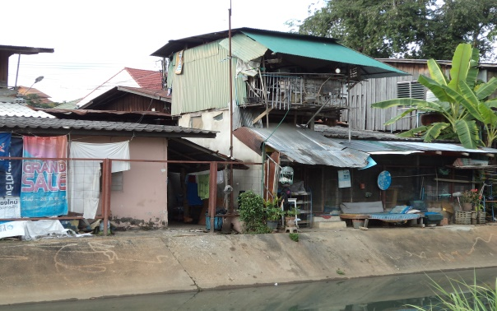Industrialisation and urbanisation have, together, polluted Mae Kha Canal. It is not uncommon, for example, for factories and restaurants to operate along the Mae Kha Canal. Factories and restaurants discharge wastewater, which has made the water turbid, rancid, and contaminated. Into the canal, people throw not only such everyday rubbish as plastic bags and nappies, but also such large items as soiled mattresses and junk refrigerators, all of which have clogged the canal. The Chiang Mai authority has dredged up the canal several times. However, the canal remains highly polluted.

Pollution is not the only problem in the Mae Kha Canal. A nearby community, known as Kampaeng Ngam, has suffered threats of eviction levelled by the Thai central government. The problem is that many people in Kampaeng Ngam built their homes on the historical wall known as Kampaeng Din, which is under the jurisdiction of the Fine Arts Department of the Ministry of Culture of Thailand (Ribeiro & Srisuwan 2005: 174). The situation for these people has become nearly untenable.

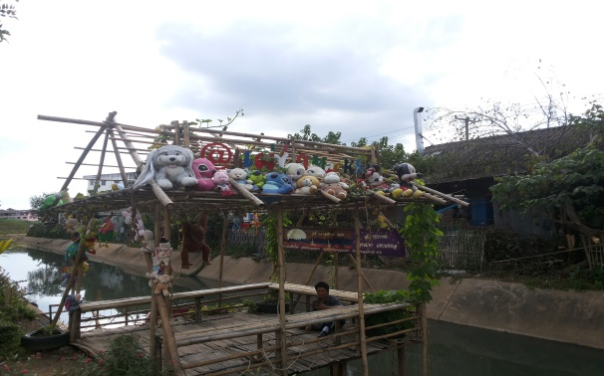Mae Kha Canal is a potential site for transdisciplinary studies. The essence of such research is that its expertise “is conferred upon individuals in different and multiple circumstances,” not just upon individuals in academia (cited from Bracken et al. 2015: 1293). Against this backdrop, an effective way to conduct transdisciplinary studies is to promote cooperation between academic and non-academic stakeholders. Non-academic stakeholders can be a person, group, or organisation possessing dynamic local knowledge “built from experience of living in a place over an extended period of time” (cited from Bracken et al. 2015: 1293). In the example of Mae Kha canal, eviction and pollution have attracted the attention of non-governmental organisations (NGOs). These NGOs include the Community Organization Development Institute (CODI) and the People’s Organization for Participation (POP). NGOs have created several programmes that empower local residents by strengthening their ability to protect the surrounding environment (Ribeiro & Srisuwan 2005: 178–81). In recent years, local residents have been taking an ever-growing interest in activism that promotes environmental and social justice. At the same time, researchers at Chiang Mai University have studied these events and themes in cooperation with NGOs and local residents.

**References:**

Bracken, L. J., H. A. Bulkeley, & G. Whitman. 2015. Transdisciplinary Research: Understanding the Stakeholder Perspective. *Journal of Environmental Planning and Management* 58(7): 1291–1308.

Ribeiro, G. & A. Srisuwan. 2005. Urban Development Discourses, Environmental Management and Public Management and Public Participation: The Case of the Mae Kha Canal in Chiang Mai, Thailand. *Environment and Urbanization* 17(1)

**_____________**

**No. 8 Mae Chaem district, Chiang Mai**

Mae Chaem district is about 115 kilometres west of Chiang Mai city. Its elevation ranges from 400 to 2,565 metres above the mean sea level. Over 70 percent of the district area is mountainous with relatively small arable land. Five major ethnic groups live in this district – Lua, Karen, Hmong, Lisu, Northern Thai. Development programs involving several government agencies and missionary works entered the area since the 1950s. Opium cultivation emerged in the 1970s. The United Nations declared the district as a principal area of opium cultivation in the 1980s. Many government development programs with the support of the UN, as well as the Royal Project Foundation had since introduced crop replacement programs in the district promoting the cultivation of temperate fruits, vegetables, and cut flowers. Some non-governmental organization also started the anti-poverty program in the district which aimed to improve community-based natural resource management while the Royal Forestry Department also operated forest conservation project.

Currently, forest degradation has been witnessed in many villages with the disappearance of forest fauna when corn farming was introduced into the area about a decade ago. The use of heavy fertilizers, pesticides and herbicides resulted in the contamination of water resources in many villages. Current issues include the restriction on the expansion of farmlands, land use conflicts, young people migration into town in search for job and education, and environmental problems including haze due to the concentration of corn farming in the district. While the proposed Mae Chaem dam as part of the previous government’s mega project on water management has been suspended, villagers and environmental groups have expressed concerns over the project revival by the military government. In the past few years, planting corn has become the only viable income option for most villagers in Mae Chaem. Unfortunately, lack of access to legal sources of loans has put many villagers on borrowing from informal moneylenders with high interest rates. Poor harvests and fluctuating prices meant that many villagers were put on heavy debt.

The field trip will deal with environment problems (haze), land use conflict, and corn plantation (cash crop). Research has been done by some students including the master student from the Centre for Ethnic Studies and other CMU faculties.

Non-academic stakeholder: Orphya Foundation (สถาบันอ้อผะหญา) working on community development and natural resource management.

Contact persons:

1. Mr. Somkiat Meetham, Orphya Foundation, Mae Chaem District, Chiang Mai.

2. Mr. Montree Padsakornwong, village head, Mae Sa Village, Mae Chaem District, Chiang Mai

Accommodation & transportation: Mae Sa or Mae Kor village, Mae Chaem district; four-hour travelling by the hired Red Car or van.

Duration in the field: 3 days 2 nights

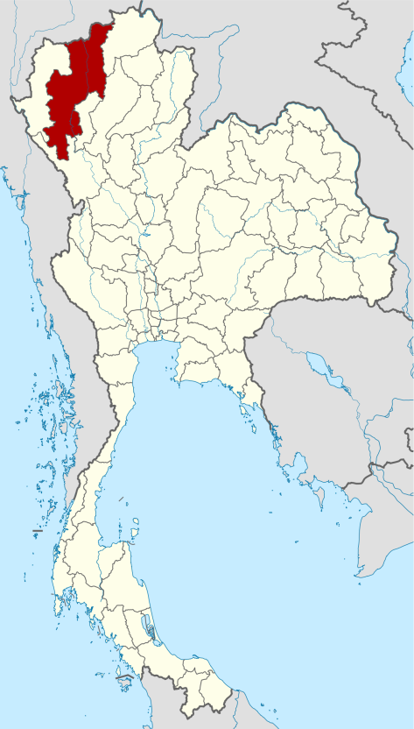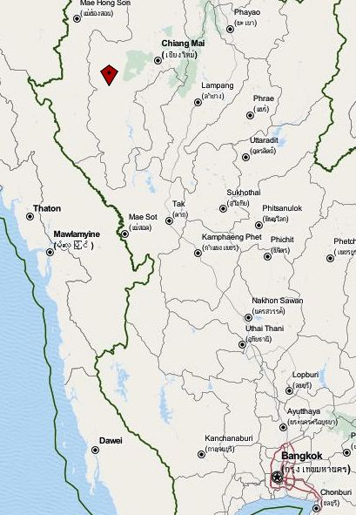

Map 1: Chiang Mai, Thailand Map 2: Mae Chaem District, Chiang Mai Province

Source: <https://th.wikipedia.org/wiki/จังหวัดเชียงใหม่>; <http://www.payer.de/thailandchronik/chronik1992b.htm>

**Notes on reflection of the summer school and field trip in Hanoi**

  * Looking at the results of the summer school feedbacks. A closer linkage of the summer school and the fieldtrip is more desirable. That also applies to the continuity of staff, teachers and students. I think we should work in this direction and ask ALL the participants to stay for summer school (ss) AND fieldtrip (ft). It makes things much smoother and guaranties the flow of all necessary information.  
  
  * Also in some of the feedbacks the question rose up, if it might be possible to link both ss but especially the ft to existing research projects or even create/start new research projects in which i.e. PhD candidates could be and could stay involved as a part of their thesis/project after the ft. is over? That would be great and very helpful for further output of the KNOTS project. Oliver is very in favour of this idea.  
  
  * A second big problem was language. We really experienced during the ss and ft a big gap between participants who were well able to express their ideas in English and others who could not do so. Even clear understanding was a problem sometimes.   So the topic of translation is important as you already mentioned.  
  
  * Concerning the further development of our interdisciplinary understanding I would like to underline your idea not to use only presentations but also workshops, discussions and the introduction of good examples of interdisciplinary research. Many of the students asked for that for clearer understanding and also some of the staff member assume that this might be helpful for our own common understanding.

*The first point is that to teach transdisciplinary research, we need to do it. I.e. the contradiction between theoretically talking about it and then doing classic "field work" as in Vietnam should be avoided. The problem is, of course, that real transdisciplinary work cannot be done in a week. A solution could be that the field work is either in locations where you or partner unis are already doing transdisciplinary research or that we would start new projects which then would have to be  
followed up. We don't have projects in your area, but we would be happy to get involved in follow up transdisciplinary work. This could either be on a larger scale (securing research funds etc) or on a low-intensity level (smaller bits of research and getting student MA theses etc. involved e.g. in connection to PhD projects etc.). This is a tall order, I know, but we are keen to support any move in this direction!  
  
*The second point is then that "theory" and "practice" need to be woven together better. So the field research could be in the middle of the summer school, with us all returning from the different projects and sharing our insights, and also teaching the students how to process data, how to continue the transdisciplinary process etc. In your description, you speak of 2-3 days field trips. This seems to us to be a bit short in order to work in a meaningful way.  
  
*The third point is then on the teaching. We could repeat and improve on the last summer school, or we could try to adopt a more interdisciplinary approach from the onset by not separating the issue migration, social equality and environment but by looking at the ways they are linked (and using different theoretical approaches that show how they are linked). We can also support you in designing the teaching (also including more active and participatory learning methods).